# IT 140 Design Document Template

## Instructions

Fill out the sections below. Be sure to remove the bracketed text before submitting your Design Document.

Caleb Ewer

## Storyboard (Description and Map)

You are an American PMC going into a Russian occupied mega mall. Your task is to grab the items need to survive this long fight. You will start at the Front Door of the mall. You will need food from Goshan to endure this long fight, a weapon from Kiba so we don’t have to go hand to hand, ammo from Generic (grab the good stuff!), Ifak from Mantis to patch ourselves up incase things go sideways, Ibuprofen from Emercom because we will need something to kill the pain and a backpack from German to put everything in. Be on the lookout though because Killa has been spotted near Brutal and he doesn’t take very kindly to visitors in his mall! Do not let me down!

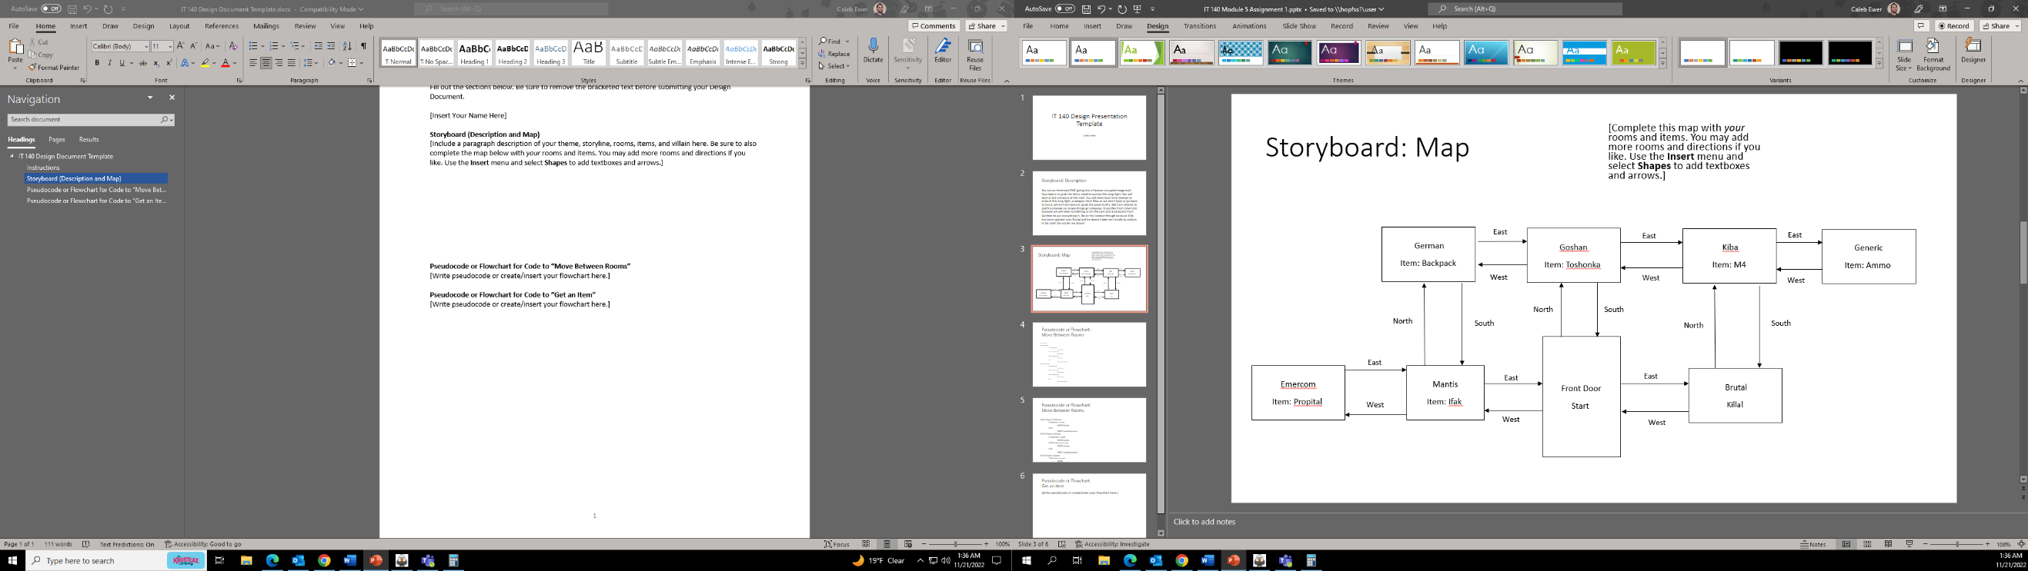

## Pseudocode or Flowchart for Code to “Move Between Rooms”

Start – Front Door

IF room is Front Door

IF direction is north

ENTER Goshan

ELSE IF direction is west

ENTER Mantis

ELSE IF direction is east

ENTER Brutal

ELSE

PRINT ‘Invalid direction’

ELSE IF room is Mantis

IF direction is north

ENTER German

ELSE IF direction is west

ENTER Emercom

ELSE IF direction is east

ENTER Front Door

ELSE

PRINT ‘Invalid direction’

ELSE IF room is Emercom

IF direction is east

ENTER Mantis

ELSE

PRINT ‘Invalid direction’

ELSE IF room is German

IF direction is south

ENTER Mantis

ELSE IF direction is east

ENTER Goshan

ELSE

PRINT ‘Invalid direction’

ELSE IF room is Goshan

IF direction is west

ENTER German

ELSE IF direction is east

ENTER Kiba

ELSE IF direction is south

ENTER Front Door

ELSE

PRINT ‘Invalid direction’

ELSE IF room is Kiba

If direction is west

ENTER Goshan

ELSE IF direction is east

ENTER Generic

ELSE IF direction is south

ENTER Brutal

ELSE

PRINT ‘Invalid direction’

ELSE IF room is Generic

IF direction is west

ENTER Kiba

ELSE

PRINT ‘Invalid direction’

ELSE IF room is Brutal

IF direction is north

ENTER Kiba

ELSE IF direction is west

ENTER Front Door

ELSE

PRINT ‘Invalid direction

## Pseudocode or Flowchart for Code to “Get an Item”

DISPLAY current room

DISPLAY items in current list

IF item in room

DISPLAY item

IF get equals true

IF item is in current list

DISPLAY ‘Item is already in list

ELSE

ADD item in current list